Independence Sicilian Heritage Festival

Downtown Independence, Louisiana

Spaghetti Cook-Off

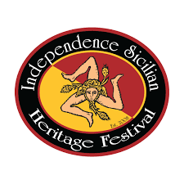

DESSERT CONTEST
Enter your best Italian/Sicilian Dessert
(You don’t have to be in the Spaghetti Cook-Off to enter.)
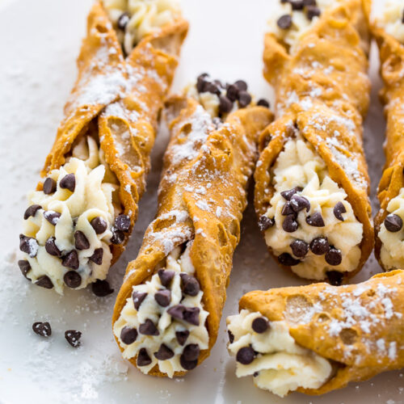
- Drop off entries Saturday, March 7, 2026 between 8:00-8:30 a.m. at the Pavilion at Festival Square
- 1st, 2nd, & 3rd place
- $10 per dessert entry

Name: ________________________________________
Dessert: ________________________________________
Phone: ________________________________________

