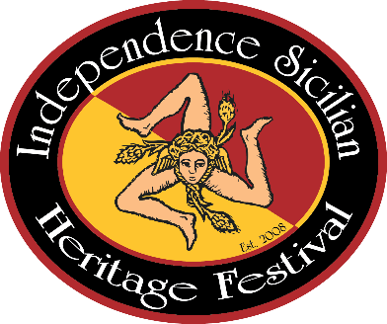
Independence Sicilian Heritage Festival
Downtown Independence, Louisiana
___________________________________
Spaghetti Cook-Off Entry Form
March 2, 2024

Team Name: ________________________________________________________

Head Cook: ________________________________________________________

Assistant 1: ________________________________________________________

Assistant 2: ________________________________________________________

Address: ________________________________________________________

Phone: ________________________________________________________

Tent Size: 10x10 10x20 Other:___________________(size)

Entry Fee $50

The Spaghetti Cook-Off is now located in Festival Square by the new pavilion in downtown Independence. Tents will be set up in a “U” formation next to Dr. Genovese’s office. You may drop off your supplies at the location and park your vehicles to the north or south of Festival Square.

Each team is responsible for bringing everything necessary to cook their gravy and for their table display. Some items could include pots to cook gravy and spaghetti, utensils, tables, and chairs for your area. Meatballs can be made ahead of time at home. The gravy must be made on the grounds the day of the cook-off.

There will be a People’s Choice Award. For a donation of $3, individuals can cast their vote for their favorite gravy for the People’s Choice Award.

