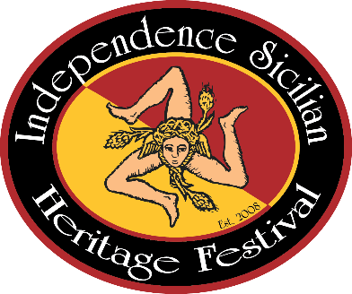
Independence Sicilian Heritage Festival
Downtown Independence, Louisiana
___________________________________
Spaghetti Cook-Off
DESSERT CONTEST

Enter your best Italian/Sicilian Dessert
(You don’t have to be in the Spaghetti Cook-Off to enter.)

- Drop off entries Saturday, March 2, 2024 between 8-8:30 am at the Pavilion at Festival Square
- 1st, 2nd, & 3rd Place
- $5 per Dessert Entry

NAME: ____________________________________________

DESSERT: _________________________________________

PHONE: ___________________________________________

