Independence Sicilian Heritage Festival

Downtown Independence, Louisiana

Spaghetti Cook-Off
March 7, 2026
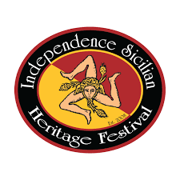

The following awards will be presented:
- Best Red Gravy – 1st, 2nd, & 3rd
- Best Homemade Meatball – 1st, 2nd, & 3rd
- Best Sicilian Themed Table Display – 1st, 2nd, & 3rd
Themes: Culture, Religion, Appearance, Color, & Layout
- OVERALL Champion (highest cumulative score)
- People’s Choice
Spaghetti Cook-Off Rules & Regulations:
- Entry Form and fee accepted until 8:00 a.m. on March 7, 2026
- Set-up begins at 7:00 a.m. on March 7, 2026
- Judging begins at 12:00 p.m.
- Gravy must be prepared on location the day of the cook-off.
- Meatballs can be made in advance.
- Contact: Jeanette Patanella @ 985.507.3123
- Please mail forms to:
Jeanette Patanella
P.O. Box 276
Independence, LA 70443

